**Risk Analysis**

# Break Even Analysis

* 
* 





# Sensitivity Analysis

* 
* We typically **assume the Base Case** and then **change exactly one of the variables** to be Worst/Best
* The sensitivity range is the difference between the NPV calculated using the Best and Worst variable
* We repeat this process for all possible variables - the variable with the **highest range is the most sensitive**

Units sold 
Price per unit ($) 
Tax rate 
Cost of capital 
Base Case 
1,000 
300 
40% 
15% 
Worst Case 
800 
240 
50% 
20% 
Best Case 
1,200 
360 
30% 
10% 

V ariable 
Units sold 
price per unit ($) 
Tax rate 
Cost of capital 
NPV 
(Base Case) 
253,275 
253,275 
253,275 
253,275 
NPV 
(Worst Case) 
152,710 
132,597 
189,584 
190,367 
NPV 
(Best Case) 
353,840 
373,953 
316,966 
329,597 
Range 
201,129 
241,355 
127,382 
139,230 

# Scenario Analysis

* 
* Similarly, we typically assume Base, Pessimistic and Optimistic scenarios - the greater the range of NPVs, the riskier the project
* Note that the variables in Scenario Analysis are **interconnected** thus the values chosen for each scenario have to be **internally consistent** with one another

V ariable 
Units sold 
Price per unit (S) 
Tax rate 
Cost of capital 
NPV 
Pessimistic 
Scenario 
800 
240 
50% 
20% 
(12,995) 
Most Likely 
Scenario 
1,000 
300 
40% 
15% 
253,275 
Optimistic 
Scenario 
1,200 
360 
30% 
10% 
725,355 

Most Likely 
Scenario 
Probability 
Pessimistic 
Scenario 
25% 
Optimistic 
Scenario 
Then, the expected NPV is: 
E[NPV] = + + 
= 304,727 

# Monte Carlo Simulation

* Method of estimating the outcomes of an uncertain event which help to **quantify risk**
* 
  + 
  + 
  + 
  + If the **true underlying distribution** is given, then these values have to be computed ourselves
* 
  + If the random number falls between the region defined for a particular outcome, then we count it as that outcome has been sampled
  + Repeat this process for a large number of times to obtain a large sample of observations
* We assume that this **sample is representative** of the distribution
  + Calculate sample statistics such as **Mean and Variance**
  + Use the CDF inverse to solve for a generated variable
* Note that variables are ALLOWED to be dependent on one another - in which case, the joint distribution of variables is required rather than a single distribution

|  |  |  |
| --- | --- | --- |
| **Poisson** | **Uniform** | **Exponential** |
|  |  |  |

Note that for discrete distributions, we add **manually add up** the individual probabilities

**Conditional Uniform Distribution**





* Applicable when the Uniform distribution draw only occurs if another condition is satisfied
* 
* Set **conditional CDF equal to original CDF** and solve for the value required

# Comparing all four methods

* **Break Even Analysis** → Accounts for **time value of money**
* **Sensitivity Analysis** → Determines **which variables are most influential** on the project
* **Scenario Analysis** → Similar to sensitivity analysis but accounts for **inter-connected variables**
* **Monte Carlo →** Accounts for ALL sources of uncertainty as all possible combinations are considered
  + Another difference is that Scenario Analysis looks at a single NPV while Monte Carlo is concerned with the distribution of NPVs

**Real Options**

# Real Options

* They are options that give the manager the right (NOT obligation) to make a business decision **in the future** after new information becomes available
* The difference between Real and Financial Options are that the underlying assets for Real options are not traded in financial competitive

# Decision Trees without Real Options

* Decision Trees are a graphical method of evaluating decisions in an uncertain environment
  + **Square Nodes** → Decision needs to be made
  + **Circular Nodes** → No control over outcome
* It is then filled with key information about the project such as Payoff, Cost & Probability
* Based on the information, we can calculate the **expected profit** for each decision & then **pick the decision with the higher expectation**

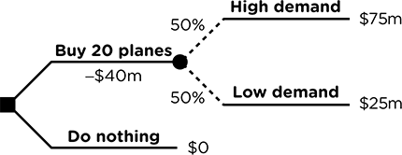

Note that **NOT all decisions are made at time 0** - given a decision, we will always only choose the better option, which means that **payoff of the other option is set to 0**

# Decision Trees with Real Options

## Growth Options

* Consider the same project to buy a fixed a number of planes - but instead has the option buy part of the planes now and **grow the purchase later**
* This gives the flexibility to double down in a good scenario (Increasing Revenue) and pull out in a bad one (Cutting Loss)

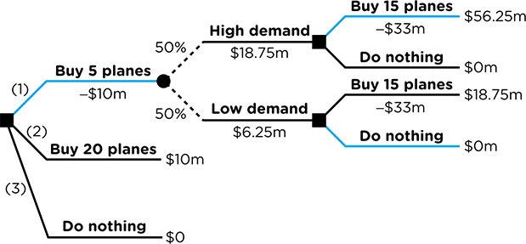

Without the Growth Option,







Using the Growth Option, the company **will not expand** the purchase under the bad scenario,









## Abandonment Option

* Consider a project that will last for a **fixed number of years** - Instead of *fully committing* to the project, the company goes through one year and have the **option to abandon** the project after that
* This gives the flexibility to double down in a good scenario (Increasing Revenue) and pull out in a bad one (Cutting Loss)

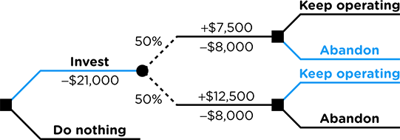

Without the Abandonment Option,







With the Real Option, the company **will abandon** the project under the bad scenario,









## Timing Option

* Consider a similar project to buy planes - but instead has the option to **delay the purchase** by a fixed amount of time and then decide if they want to purchase
* This gives the flexibility to only commit in a good scenario, **avoiding a bad one entirely**

Naturally, the project will only be taken if the PV of the project is greater than the initial cost,







* For **Uncertain Cashflows** like the PV, we discount using the **Cost of Capital**
* For **Certain Cashflows** like the Cost, we discount using the **Risk Free Rate**

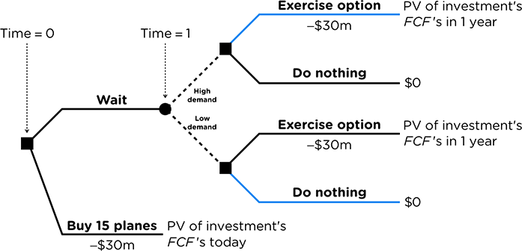

### Factors Affecting Timing Options

* **NPV of Investment** → Investments that have initially **negative expected NPVs** can have a positive NPV after considering the timing option; **Option adds value**
* **Volatility →** Investments that have **high volatility benefit more** from the option to wait
* **Dividends** → The timing option may forego some initial cashflow similar to dividends on a call option - similarly, if there are **no cashflows to be foregone**, then the **option to wait is more valuable**

